**JAVA**

Most of the project parts pretend on object-oriented and class-oriented therefore Java language was used as coding language. Since java offers various APIs for the development as well as Java is having a great community is also a great advantage.

**Node.js**

Node.js is a JavaScript runtime environment it enables the infrastructure to create and execute the application system. It’s a simple, versatile, light and cross-platform approach to execute the code segment. It utilizes an event-driven IO model which makes it extremely proficient.

**Android Studio**

Android Studio used as the IDE (Integrated Development Environment) for the HireBuddy system. Android Studio is the official IDE for android based application development and it is built on JetBrains' IntelliJ IDEA software. It provides smooth service to the programmer.

**Android Platform**

Android has been the high accuracy open source platform is the main reason to select it as the running environment for the HireBuddy system. And furthermore, it is easy to popular among the market because as to the statistics most of the individuals were using Android devices. The graphical view of the android platform is as follows.

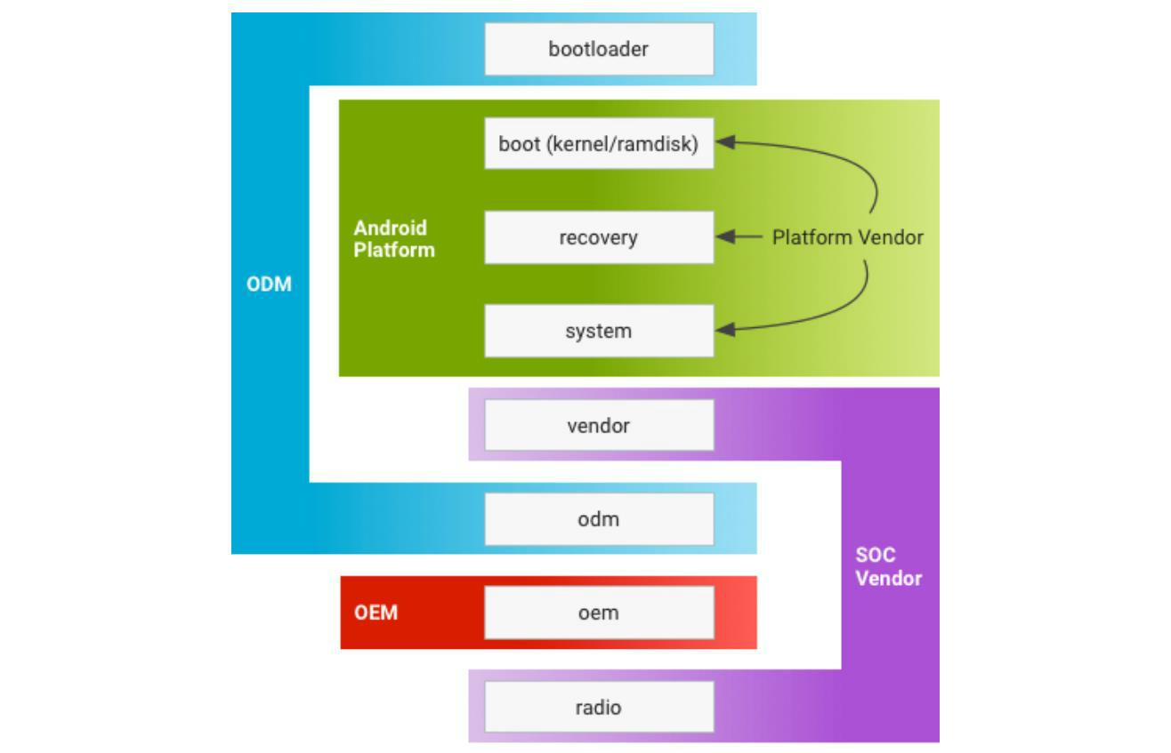

**Firebase**

Firebase consists of multiple services that help developers for their development needs. Firebase is popular because of it useful in building application integrated with a real-time database. Right now, most android based applications are using firebase since its feature. Such as Crash Reporting, authentication, storage capabilities, cloud messaging.

Easy to read documentation
 